01/02/2024

Tan Tee May
No.41, USJ11/1K,
UEP Subang Jaya,
47620 Subang Jaya,
Selangor, Malaysia.

Dear Tee May,

Subject: Appointment as a Senior Content Creator

We are pleased to offer you an appointment as a Senior Content Creator at Apply Radar Sdn. Bhd., effective 26th February 2024. You will be supervised by the director throughout your probationary period.
The following are the basic terms of your employment:

- Contractual Employment

Probationary Period: 26th February 2024 until 25th May 2024
You shall start your tenure with the company on 3 months’ contract , upon acceptance of this letter. Please take note that this will be a probationary period to gauge your suitability for the role. During this period, your performance progress will be discussed with you via a monthly evaluation process.

Upon Completion of Probationary Period
If your performance meets the company's expectation during the probationary period, you will receive a new employment contract for 1 Year on an auto-renewal basis. If your performance during the probationary period is below expectation, the contract may be extended for a shorter duration, shortened or terminated, subject to the management discretion.

Scope of Employment: You agree to perform such duties and services as the company may reasonably require you to do so. You will not, without prior written consent, engage in any other business or profession, or may be employed in any capacity by any other person or entity during the term of this contract.

- REMUNERATION PACKAGE

Your remuneration package commencing from the next salary date is: -

- Basic Salary per month  - Outpatient Medical Claims  - Transportation Allowance | : RM5, 200  : RM500 *pro-rated  : RM0.50 per km, toll and parking claimable.
Terms & Conditions:
- The Company has the right to alter or amend the terms and conditions if necessary and you, the employee, will be duly notified.
- Outpatient Medical Benefits will be paid based on claim by receipt. Staff serving less than a year will benefit on pro-rated basis.
- Transportation claims apply for travelling for work-based appointments to and from the office ONLY. Claims cannot be made for commuting-based travel.

- STATUTORY CONTRIBUTIONS AND DEDUCTIONS

- EPF Contributions
Your portion deducted from salary – 11%
Company’s contribution – 13%
(The company shall contribute EPF for the employee based on the updated EPF contribution schedule. Any changes will be imposed according to new rules and regulations from EPF)

- SOCSO & EIS Contribution
The company shall contribute each month of the employee’s salary for that month based on SOCSO & EIS contribution schedule.

- Income Tax
Personal taxes as required by Malaysian law will be deducted monthly from your salary.

- WORKING HOURS

- Mon - Friday  - Weekends | : 9.30am – 6.00pm (including lunch break)  : You must be prepared to work on weekends or public  holidays when necessary: ie: if there is an event/ purpose  which covers your scope of work.

- ANNUAL LEAVE, SICK LEAVE AND PUBLIC HOLIDAYS

- Annual Leave
Entitlement to earned Annual Leave:
Annual Leave : 3 working days during the 3 month contract period.
The Company must be given 1 weeks’ notice in writing for annual leave applications.

(b) Sick Leave
Sick Leave : 3 working days during the 3 month contract period.
The medical certificate must be submitted to the company upon return to work.

(c) Public Holidays
All gazette National and State public holidays will be observed by the Company. However, because of the nature of our business, you may be required to work on a Public Holiday.

- SERVICE

It is a condition that you shall: -

- Devote your whole time, attention, energy and skill solely to the business of the Company and shall not be concerned directly or indirectly in any business or work other than the Company.
- You shall not disclose any sensitive information concerning the business or finance of the Company or any dealings, transactions, or affairs, which may come to your knowledge in the course of your employment with the Company.
- You will not make any press announcements or issue any statement to media or grant any interview with media on matters concerning the Company and its customers without obtaining the consent of the Company.
- Abide all proper orders, instructions, rules and regulations of the Company.
- Exercise due and proper care and attention when using all equipment and assets of the Company.
- Come to work on time and finish task of the day.
- Report in and out of work on daily basis unless approved by your immediate superior.
- Submit daily call reports to your immediate superior
- Be neat and clean at all times.
- Conduct yourself in a professional and respectful manner in all dealings with customers, fellow employees and management.

The Company will reserve the right to claim from you for any damage or losses suffered in respect of the Company’s assets arising from your negligence or mishandling.

- TERMINATION

- The company may without prior notice terminate this contract or suspend you from your duties (with or without pay or allowances, at sole discretion of the company) if you:

  - Willfully neglect the company interest.
  - are absent from duties without approved leave or other valid reason.
  - Are guilty of disobedience, misconduct or off duty prejudicial to the company’s interest. Or
  - From your own fault, sick, disabled or otherwise unable to properly perform your duties.
  - Deliberately fail to follow the company policies and procedures as communicated to you from time to time.
  - Are unable to perform your duties on more than one occasion without reasonable reason.
  - Extend your leave for personal reason without prior written consent approval

- In the event of termination of employment whilst in contract period, either party shall give One (1) month written notice. Payment in lieu therefore for such may be exercised.

- Please note that if convicted of a felony in a court of law the employer may exercise the right to terminate this employment contract immediately.

- CONFIDENTIALITY & NON DISCLOSURE AGREEMENT

You therefore agree to abide by the provision of the Confidentiality and Non-disclosure Agreement attached herewith as Appendix 1, and which shall form part of this agreement.

- PERSONAL DATA PROTECTION ACT (PDPA)
Pursuant to Personal Data Protection Act 2010 (“PDPA”), the Company requires all employees to comply with the Company’s PDPA policy in relation to the information about other staff. Failure to do so will be regarded as serious misconduct and will be dealt with in accordance with the Company’s disciplinary policy and procedure. The Company’s PDPA policy is detailed in the attached Appendix 2.
- OTHERS

All other terms and conditions not specified herein shall be in accordance with current practice, Company’s General Policies and Guidelines and the labor laws of Malaysia.

Neither party shall be liable for any costs or damages due to delay or non-performance arising out of any cause or event beyond such party’s control, including, without limitation, cessation of services hereunder or any damages resulting therefrom to the other party as a result of work stoppage, power or other mechanical failure, computer virus, natural disaster, governmental action, global health emergency or communication disruption.

- ALTERATIONS

If, for any reason whatsoever, the company wishes to alter these terms and conditions of service, it reserves the right to do so entirely at its discretion. Any alteration, amendment or addition to these terms and conditions of service will be advised to you accordingly in writing.

If the above are acceptable to you, please indicate your acceptance by signing and returning the duplicate copy of this letter.

We take this opportunity to thank you for your interest in Apply Radar Sdn. Bhd. We wish you all the best and may your career with the Company be a long and rewarding one.

Yours Sincerely,

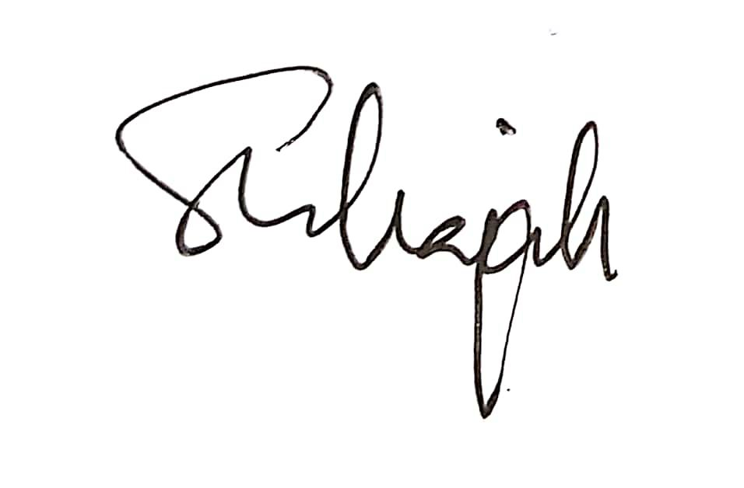
………………………………………….
Nadarajah Sivalingam
Managing Director

EMPLOYEE ACKNOWLEDGEMENT:

I, Tan Tee May, IC No. 930409-14-6496 hereby have read, agreed and accepted the above terms and conditions. I will report for duty on the 26th February 2024.

_______________________ (signature)

Name:

Date:

Appendix 1

CONFIDENTIALITY AND NONDISCLOSURE AGREEMENT

This agreement is a condition of employment pursuant to the paragraph 9 of the Employment Contract between you and the Company and is incorporated by reference into that contract.
In connection with the Employee’s employment commencing on 26th February 2024 the above parties acknowledge that Confidential Information may be disclose by the Company to the Employee during the period of the employment.
As a condition to being furnished such Confidential Information, the Employee agrees to treat such Confidential Information furnished or disclosed on or after the effective date hereof, in accordance with the provisions set forth herein.

- Confidentiality.
  - The Employee acknowledges that effective on the date of this Agreement, the Employee will have access to, and be entrusted with, Confidential Information of the Company and its clients and their respective dealings, transactions and affairs, all of which information is or may be confidential.
  - The Employee shall not (except in the proper course of duty as an employee and except as provided for by paragraph 2 below) during or after the Employee’s employment:
- Make use, divulge or communicate to any person whomsoever or otherwise make use of, whether for the Employee’s own benefit or for the benefit of any other person, firm, company or association (and shall use the Employee’s best endeavours to prevent the publication or disclosure of) any trade secrets, or any Confidential Information of the Company or its clients;
- Make use, divulge or communicate to any person whomsoever or otherwise make use of, whether for the Employee’s own benefit or for the benefit of any other person, firm, company or association (and shall use the Employee’s best endeavours to prevent the publication or disclosure of) any discussions or negotiations concerning the works or projects contemplated by the Company or its clients and/or any possible transactions undertaken with/by the Company or its clients or any of the terms or conditions of possible or actual transactions (including but not limited to any resultant contracts) undertaken with/by the Company or its clients;
- Retain Confidential Information of any client or business associate of the Company; or
- Be held out or represented by any other person, as in being in any way connected with, or interested in the Company or its clients.
This duty of confidentiality shall survive the tenure of employment of the Employee.
  - All documents, drawings, specifications, patents, copyrights, data, trade secrets and other tangible or intangible materials containing any Confidential Information of the Company or its clients which shall be acquired, received or made by the Employee during the course of the Employee’s employment shall be the property of the Company (or its clients, as the case may be) and shall be surrendered by the Employee to a person duly authorised in that behalf at the cessation of the Employee’s employment or at the request of a Director of the Company at any time during the course of the employment.

- Permitted Disclosure
The obligations of confidentiality assumed by the Employee pursuant to this Agreement shall not apply to the extent that such information: (i) is a matter of public knowledge without any breach of this Agreement by the Employee; (ii) was disclosed to the Employee by a third party who or which is not required to maintain its confidentiality; or (iii) is the subject of a written agreement whereby the Company consents to the disclosure of such Confidential Information by the Employee on a non-confidential basis or (iv) is already known to the Employee prior to entering into this Agreement.

- Consequences of Breach
The Employee acknowledges and agrees that the Company and/or its clients may be irreparably harmed by the breach of the terms hereof and damages may not be an adequate remedy and that the Company and/or its clients may seek a court order or an injunction or specific performance for any threatened or actual breach of the provisions of this Agreement by the Employee.

- No Waiver
The parties agree that no failure or delay by either party in exercising any right, power or privilege hereunder will operate as a waiver thereof nor will any single or partial exercise of any right, power or privileges hereunder preclude any further exercise thereof or the exercise by the other party of any other right, power or privileges hereunder. The terms of this Agreement and the parties’ obligations hereunder may only be amended or modified by written agreement between the parties hereto.

- Period of Disclosure/Termination
This Agreement covers only Confidential Information disclosed between the Effective Date and 2 (two) years thereafter. This Agreement and each party’s obligations hereunder, shall expire 2 (two) years from the Effective Date. However, either party may terminate this Agreement at any time upon 30 (thirty) days prior written notice to the other party, upon which Recipient will cease use of and return or destroy all Confidential Information. In the case of termination, all provisions of this Agreement shall survive for a period ending 2 (two) years from the Effective Date.

- Entire Agreement

  - This Agreement shall be governed and construed and enforced in accordance with the laws of Malaysia and the parties irrevocably agree to submit to the exclusive jurisdiction of the Malaysia courts in all proceedings arising out of this Agreement or its terms.
  - Any provisions of this Agreement which are expressly provided to survive the expiration or sooner termination of the Agreement shall so survive, including but not limited to the confidentiality provision.
  - This Agreement represents the complete and full understanding of the parties with respect to the subject matter hereof, and supersedes all prior representations and understandings, whether oral or written.
  - If any provision of this Agreement is invalid or unenforceable under applicable law, that provision shall be enforced to the maximum extent possible and the remaining provisions shall remain in full force and effect.
  - This Agreement shall be binding on the parties and their respective successors.

- Definitions and Headings
In this Agreement unless the context otherwise requires:
“Confidential Information” means any information and documents concerning the Company’s (and its clients’) business, affairs, operations, assets, organisation, dealings, client/customers, suppliers, employees, staff, partners, financial and other information, trade secrets, plans, data, developments, processes, procedures, operations, market research, marketing techniques and plans, business plans and strategies, fees policies, investment portfolios and other business and/or technical information and materials, in oral, written, electronic, graphic or machine-readable form, and any analyses, compilations, studies or documents which summarize such information. Confidential Information shall also include such information or material proprietary to or relating to the Company (and its client which the Employee may obtain knowledge about or access to or be supplied with such information. Confidential Information also includes any information described above which the Company has obtained from another party and treats as proprietary or designates as Confidential Information, whether or not owned or developed by the Company or its clients.
The headings in this Agreement are for purposes of reference only and shall not in any way limit or otherwise affect the meaning or interpretation of any of the terms hereof.
IN WITNESS WHEREOF the Parties have executed this Agreement or caused it to be executed in their names and on their behalf by their duly authorised representatives on the date set forth.

Signed for and on behalf of Apply Radar Sdn. Bhd:


____________________
Signed by : Nadarajah Sivalingam
Designation : Managing Director
Date : 01/02/2024
Agreed and Accepted :

___________________
Employee’s Signature
Name :
Date :
NRIC/Passport No :
Appendix 2

Subject: Authorization and Disclosure
- In view of the Company required to be in compliance with the Personal Data Protection Act 2010 (PDPA) effective from 15th November 2013 we are taking steps to ensure compliance.

This letter gives details about the type of information that Company keeps about its employees and the purposes for which Company keeps them.

- Please be informed that your personal information is being processed by Company for following purposes (“Purpose”): -

- Information gathered about an employee and any references obtained during recruitment
- Details of terms of employment
- Income Tax, EPF & SOCSO
- Performance information
- Details of grade and job duties
- Health records
- Absence records, including holiday records and Medical Certificate
- Details of any-disciplinary investigations and proceedings
- Training records
- Contact names, addresses and phone numbers
- Relevant third parties including government and state authorities enforcement agencies etc.

Company believes the above stated uses are consistent with our employment relationship and with the principles of the Personal Data Protection Act (“PDPA”).

- The information held will be for Company’s management and administrative use only, but from time to time, we may need to disclose such information we hold about employee to relevant third parties.

Therefore, Company requires all employees to comply with the Company PDPA compliance Policy in relation to the information about other staff. Failure to do so will be regarded as serious misconduct and will be dealt with in accordance with the Company disciplinary policy and procedure.

All employees are reminded not to disclose any personal information of our customer without approval of the management.

Yours faithfully
For Apply Radar Sdn. Bhd.,

-----------------------------------------------
Nadarajah Sivalingam
Managing Director

ACKNOWLEDGEMENT

I, Tan Tee May, IC No. 930409-14-6496,

- Authorized Human Resource Department (HRD) to reveal my personal information to the third parties stated in Paragraph 3 above;

- I also understand the consequence of failure to comply with PDPA which include fines and jail term as well as disciplinary action by the Company.

Signature: …………………………………… Date: ……………………

